# Lab 09a - Implement Web Apps

# Student lab

**Note:** This lab was done three times by me, and I was still getting the same results, I couldn’t figure out why I was not getting 2 instances on the last task, so I will upload the steps but unfortunately without getting the 2 instances like it should be.

* Task 1: Create an Azure web app

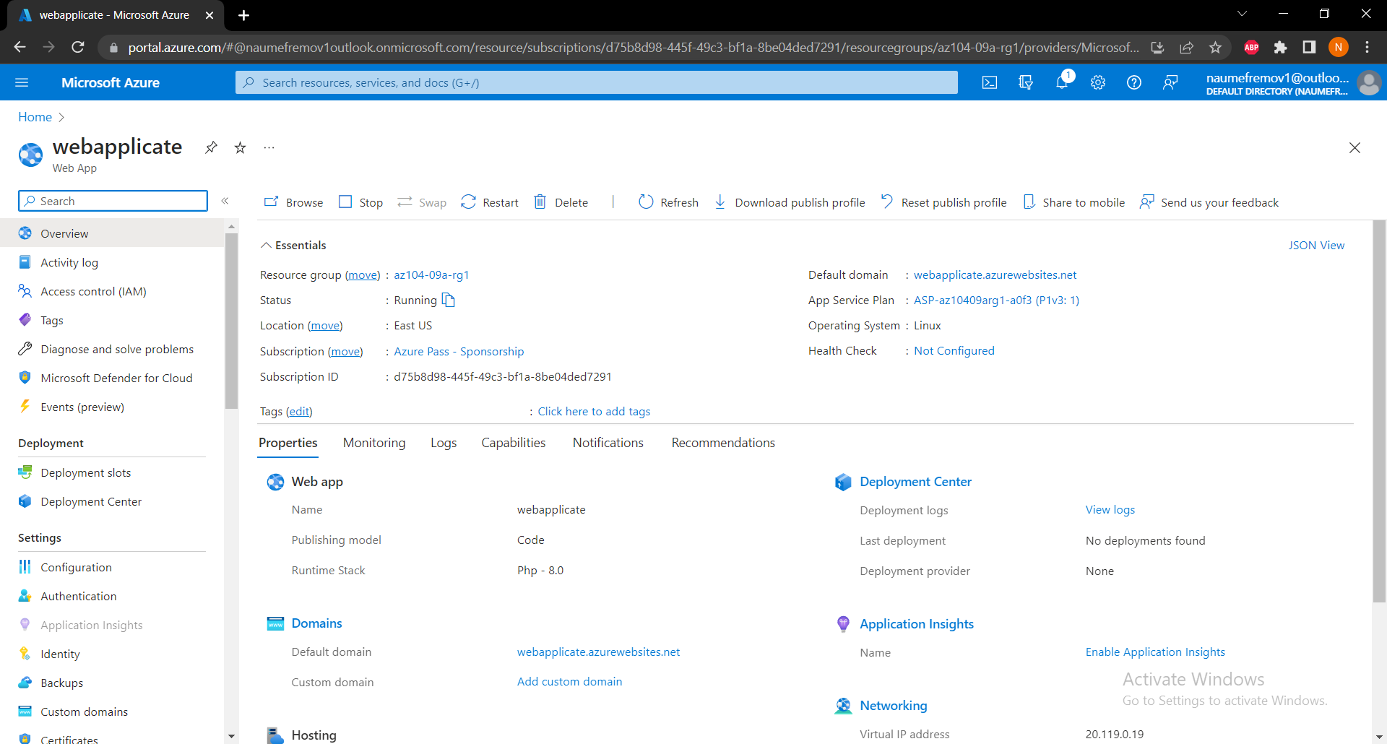

* Task 2: Create a staging deployment slot

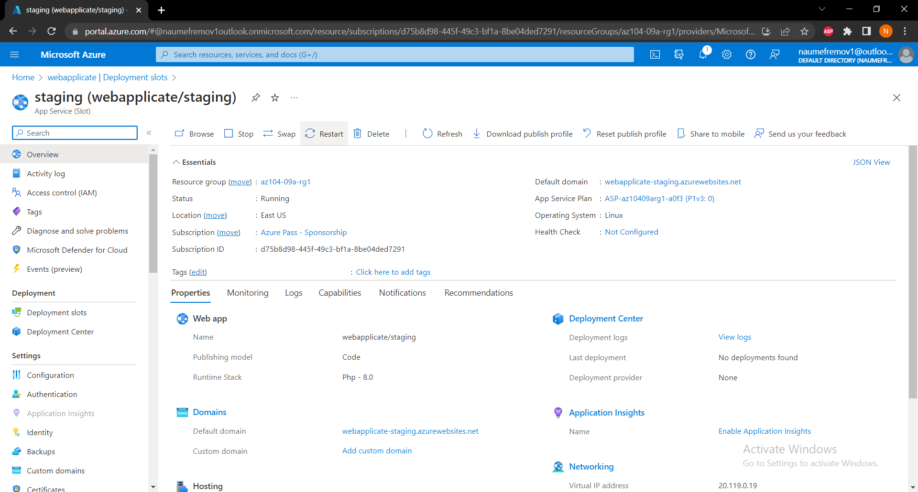

* Task 3: Configure web app deployment settings

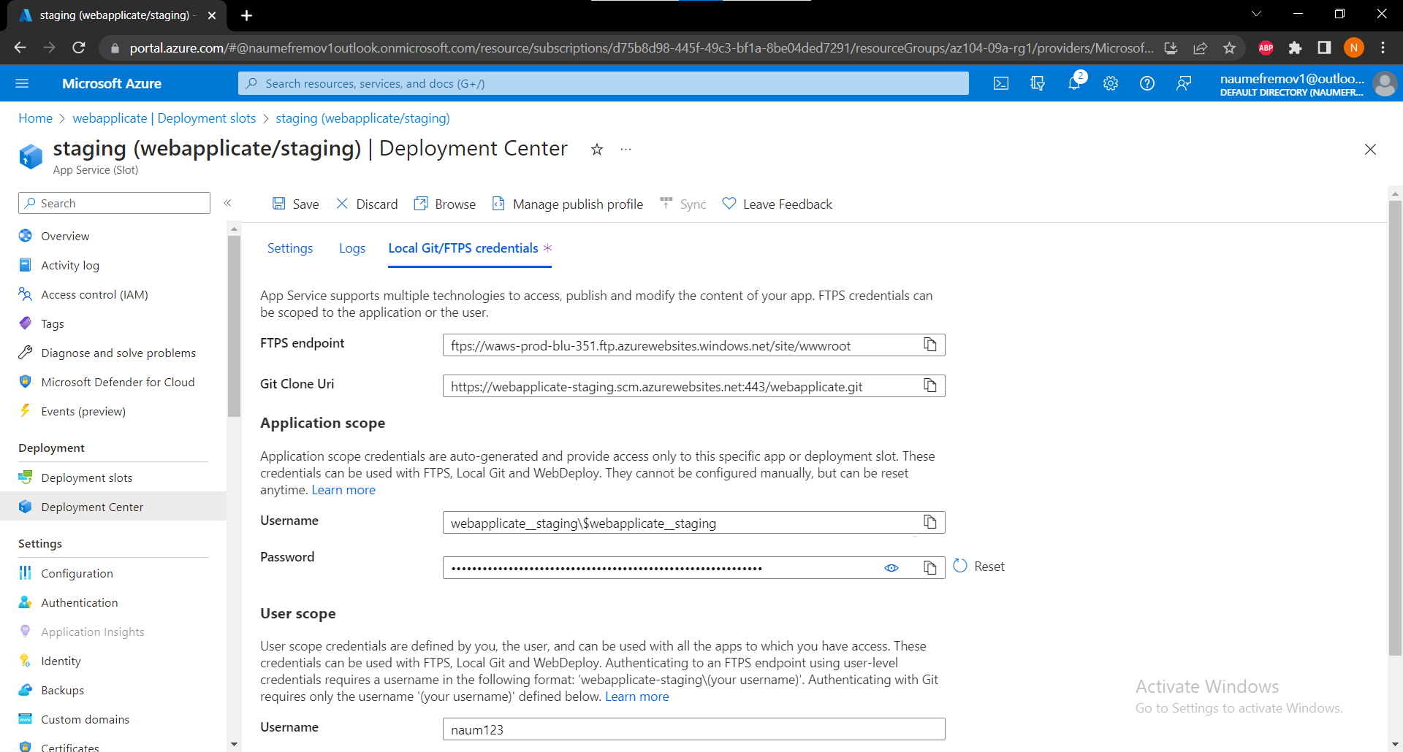

* Task 4: Deploy code to the staging deployment slot
* Task 5: Swap the staging slots

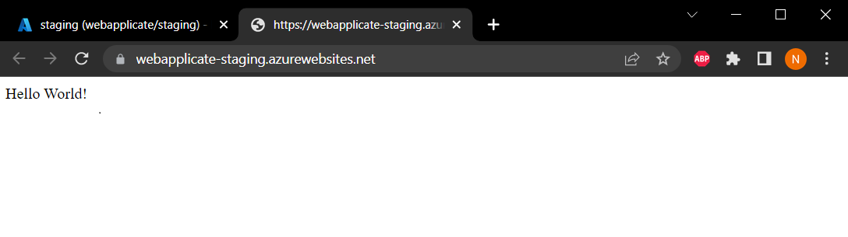

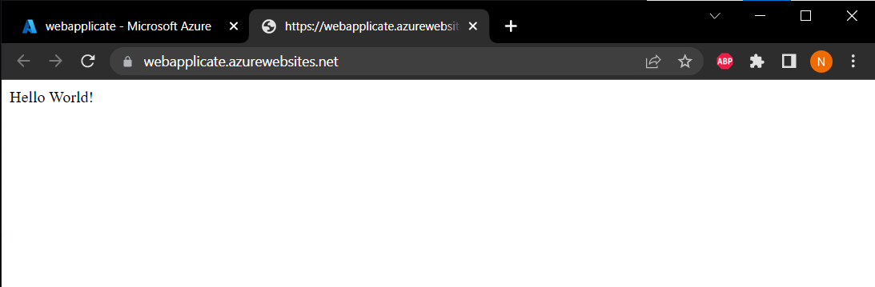

Task 6: Configure and test autoscaling of the Azure web app

